3.26

Pre market

1. FXI at 2% discount
2. VIX @ 25%
3. Work towards optimal ptf (25% stock exposure, -25% futures, intraday 25% stocks, max 25% whole ptf exposure)
4. Put vols closed at the highest (45v) on Friday close, showing extreme fear.
5. When US and HK vol is at a high level, markets will adjust, and it simply can’t rally when the vol is that high.

After market:

1. Markets still very weak
2. Cut net delta to almost flat at 350k
3. Leaving no overnight exposure going forward while vols are high
4. Rebound started at 2pm and ptf rebounded by 20k
5. Started trading too early again today. Focusing on PM is hard because of the tendency to trade too early.
6. Front month vols are at 37
7. Don't have wishful thinking, always keep delta fully hedged overnight
8. Survival first.

3.26

Overnight:

1. US rebounds overnight, VIX cash @ 21
2. Big caps @ 50 bps premium
3. HK poised to open up 80 bps

Trading Plan

1. No AM trading
2. Keep AM risk to a minimum
3. Do some PMCL in the PM
4. Eliminate most of the overnight and AM risk. Only trade core competitive advantage.

Thoughts

1. In the long run, China underperforms the other stock markets
2. Bull markets happen and die fast
3. Bear markets are long
4. When US adjusts, China suffers from huge negative OPC (opens down -2%). When US becomes volatile, hedge overnight
5. People lack solidarity and focus on selfish gains, this causes a lot of greed and panic behavior
6. Futures should be used as a hedging tool, not speculation.
7. Small gains by intraday trading are usually wiped out when markets move a lot
8. China has long run economic and political uncertainty.
9. China’s experience with the market is less than 30 years. People are very speculative.
10. Social proof plays a big part in Chinese investing, this will cause markets to swing hugely.
11. This will mean that Chinese markets will be very volatile
12. Most investors lack tools to trade on the short side.
13. Experienced trades manage risk by having a small position, but they still suffer from opening loss.
14. The key to long run survival is first, manage overnight risk, secondly, manage crash risk.
15. Made money in 2017, but a month of high vol in 2018 is enough to wipe all of that out, meaning that risk management during crises is paramount.
16. In Jan, I had a modest position and towards the end of Jan, I added a lot of position at the beginning of Feb, delta went through the roof with 1.5 times leverage.

After market:

1. Front month vols off by 5v, atm @ 34v, compared with 20v last week still high
2. Options expire tomorrow, expected move over tomorrow is over 2%.
3. Hedging is still important at this level of vol and market sentiment
4. VHSI opened low and climbed to the highest level of the day @ 24.8
5. Today buying in PM resulted in flat pnl
6. There is no position accumulation after 2, this needs to be changed.
7. Stocks bottomed out between 14:10 ~ 14:20
8. Position accumulation needs to be such that you can still put on position at 14:20.
9. Missed 14:00, 14:15, 14:30 buying opportunities
10. Can buy all the way up to 14:30

**3.28 Wednesday**

Pre-market

1. SPX -2%, Nasdaq -3%
2. VIX up 7% to 22v
3. ES fut dropped further in T+1 session
4. Hedged down -1% china open

Trading plan

1. 7 time slots from 13:00 to 14:30, trade every 15 minutes
2. Current tradable delta is 600k
3. Trade 70k per time slot for a total of 500k
4. Two stocks are traded in each time slot for 30k to 40k.
5. Hedge out AM exposure.

After market:

1. Market didn’t rebound in PM, stock day trading position still made money, showing the effectiveness of the 7 interval strategy.
2. The new method (7 trading intervals) worked well. Saved time, didn’t need to look at the market as much, did not experience stress, and made money.
3. Cover position fully going forward. No small positive exposure. No point leaving positive delta on the table.
4. VHSI up 10% to 27.4v
5. Markets nervousness level is still high.
6. Ptf vol is more controlled once hedge is implemented. Survival is key under these conditions.

**Problems with vol tool**

1. Sometimes it stops without updating (runs into an error, not robust)
2. On the close on expiry, vols go to 100.

**3.29 Thursday, March 29, 2018**

Pre market

1. VIX @ 22.9, still at high level
2. NASDAQ continues to drop
3. FXI @ 30 bps premium, ASHR -90 bps discount
4. A50 closed @ 12385 (cash 12473. 70 bps discount)
5. Issue with day trading fut is towards the close it will sell into heavy discount again, this is not good when selling positions at close, so you should not heavily trade futures when market is in a very bearish mode. Should focus on day trading stocks.
6. You should use futs to hedge when people are most optimistic, when there is no discount. It costs a lot to close off long positions at close.
7. Don’t cover futures every 15 minutes – make it every 30 minutes.

PM 14:18

1. Markets are volatile. Intraday range is 3%
2. Speculative markets -> cyb and big caps are negatively correlated.
3. Hedging reduced the intraday moves and kept effective ptf delta to 1/10 of size.
4. Ptf daily pnl after hedging has been under 0.25% (want daily pnl move to be under 10k)
5. The recent events show that hedging overnight risk is absolutely necessary
6. Cost 30 bps to roll short position, if leave stock position unhedged, that’s 25% of ptf.
7. GC001 went to 14. Most cash in the market is in stocks.
8. Tonight: hedge, leave 500k exposure. Cash 1.4mm. Roll about 10 futs.

**3.30.2018 Friday, March 30, 2018**

Pre market

1. VIX down 13% to 20v
2. SPX up 1%, NASDAQ up 1.5%
3. ASHR at 3.5%, at 1 premium
4. PD volatility is up

After market

1. Pm buying didn't work
2. Pm buying conditions need to be reset
3. Trading in stocks is expensive, 3 bps in, 13 bps out, average of 8 bps, compared with 1 bps for futures.
4. Leave stock ptf as it is unless there is a big profitability space
5. Prefer not to trade stock
6. Prefer to trade futures
7. Prefer shorting in the AM and covering short in PM.

PM buying conditions

1. Day low (Today traded a few day highs)
2. Pmcl support (ytd market closed at highest)
3. AMHO support (today there wasn’t a sizable rally)
4. Enough profitability space (today market traded within a small range)

**3.31**

Weekly review:

Stocks:

mtm: -41k

trade: +2k

overall: -39k

Future:

Overall: +9k

Whole ptf: -30k

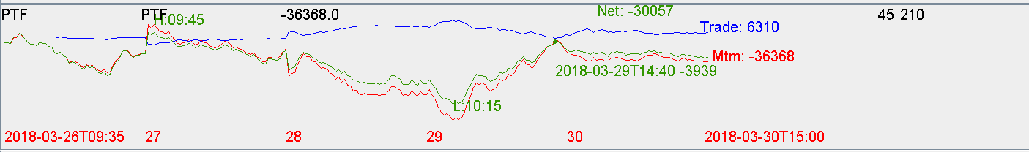

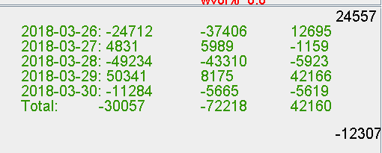

This week blue chips in the ptf were down 3%. Ptf was only down less than 1%.

Mistakes:

1. Did not check SMA20 and SMA60, these were weak for blue chips
2. When trading in the PM, didn’t pick lowest points in the day, was vulnerable
3. Traded when PMCLY was positive, fut closed at the highest the previous day
4. There wasn’t sufficient HO for the rebound (no one who bought intraday was losing money)

Going forward

1. Morning task will include checking VOL as well as the simple moving averages, simple and powerful technique to identify the current bull/bear condition
2. If below SMA, hedge overnight
3. If below SMA, hedge AM ups
4. Don’t trade without full advantage. Full advantage includes lowest of the day, sufficient AMHO, ytd down. Don’t trade PM for the sake of trading
5. Prefer trading futures over stocks due to costs (stock costs 8 bps to trade, whereas futures cost 1 bp)

This week trade pnl was 6k, which can be better

To increase pnl

1. Increase short position on the futures
2. Panic buying needs to include AM, this needs to be slower than PM. Maybe buy every 30 minutes, whereas PM is buy every 15 minutes.
3. Method needed to identify short term trading opportunities (experiment with 60 DMA of 1 minute candles, etc)

Most important takeaways

1. Hedging is crucial when below moving average